Y5
Textiles: Using Computer-aided Design (CAD) in Textiles
Context: Properties and Changes of Materials, Comparing Ancient and Modern Olympics | Possible ideas: design a sports bag, sports clothing.
Focus: Textiles: using computer-aided design (CAD) in textiles
Objectives:
- Generate innovative ideas through research and develop these using mock-ups and prototypes including using computer-aided design.
- Design functional, appealing products for the intended user that are fit for purpose based on a simple design specification.
- Select and use a range of tools and equipment including CAD, to make products that are accurately assembled and well finished.
- Work within the constraints of time, resources and cost.
TINKERCAD is free CAD software that can be accessed directly online by the whole class – suitable for upper Keystage 2.
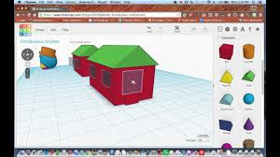

Mechanical Systems: Cams
Context: Animals, The Ganges – water cycle, Living things - habitat | Possible ideas: Make a moving toy, make a moving model related to a history/science/literacy topic eg (earthquakes, animals, story characters)
Focus: Mechanical Systems - Cams
Objectives:
- Generate a design from research; develop a specification, model and communicate ideas through speaking, drawing, CAD
- Produce lists of tools and materials and plans to make accurately assembled and well finished products within constraints.
- Compare final product to the original specification; test products with the intended user and critically evaluate the product, considering the views of others.
- Investigate famous manufacturing and engineering companies relevant to the project.
TINKERCAD is free CAD software that can be accessed directly online by the whole class – suitable for upper Keystage 2.
See Twinkl Mechanical Toy Cam Lesson Pack, has useful video/diagrammatic examples
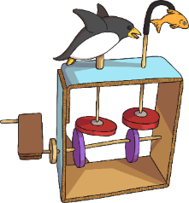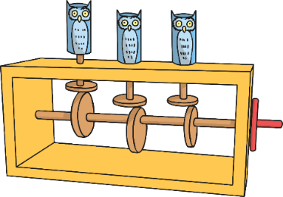

Structures: Frame Structures
Context: Living Things – Habitats, Anglo-Saxon Invasions: Settlements and Kingdoms, | Possible ideas: Design and make a bird house, design and make an Anglo-Saxon
Focus: Mechanical Systems - Cams
Objectives:
- Generate a design from research; develop a specification, model and communicate ideas through speaking, drawing, CAD
- Produce lists of tools and materials and plans to make accurately assembled and well finished products within constraints.
- Compare final product to the original specification; test products with the intended user and critically evaluate the product, considering the views of others.
- Investigate famous manufacturing and engineering companies relevant to the project.
TINKERCAD is free CAD software that can be accessed directly online by the whole class – suitable for upper Keystage 2.
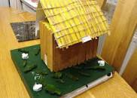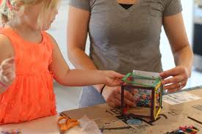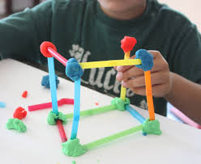

Electrical Systems: Monitoring and Controlling
Context: | Possible ideas: controlling small robot on rescue mission.
Focus: Electrical Systems – monitoring and controlling
Objectives:
- Develop a design specification for a product that responds automatically to environmental changes.
- Generate and communicate ideas through annotated sketches and representations of electrical circuits or circuit diagrams.
- Using step-by-step plan, select and accurately assemble materials, electrical components, to produce a functional product.
- Create and modify a computer control program to enable their electrical product to respond to changes in the environment.

Useful Resources:
- The Design and Technology Association website – some curriculum/skill information and free resources.
- Twinkl has some OK posters, Powerpoints and images to illustrate ideas.
- TinkerCAD: a free online computer aided design software. You need to register as a teacher and then join your class – https:/www.tinkercad.com/joinclass/4QHCRU434L6I

Y6
Mechanical Systems: Pulleys and Gears
Context: | Possible ideas:
Focus: Mechanical Systems: pulleys and gears
Objectives:
- Generate ideas through research and develop and communicate a simple design specification.
- Select and use a range of tools and equipment to make products that are accurately assembled and well finished within the constraints of time, resources and cost.
- Compare the final product to the original design specifications and test the quality of the design, manufacture and functionality.
- Investigate famous manufacturing and engineering companies relevant to the project.
TINKERCAD is free CAD software that can be accessed directly online by the whole class – suitable for upper Keystage 2
See Twinkl Pulleys and Gears Powerpoint, has useful video/diagrammatic examples

Y6
Food: Celebrating Culture and Seasonality
Context: Christmas, Ellis Island/ Mediterranean regional cooking | Possible ideas: Gingerbread to sell at Winter Café, making hot cross buns, making pasta
Focus: Food – celebrating culture and seasonality
Objectives:
- Generate and explore innovative ideas through research and discussion to develop a design brief.
- Write a step-by-step recipe, including a list of ingredients, equipment and utensils.
- Using appropriate utensils and equipment accurately, make, decorate and present food product for the intended user and purpose.
- Evaluate a range of relevant products and ingredients and the final product with reference to the design brief and specification.
- Understand seasonality and the source of different food products.

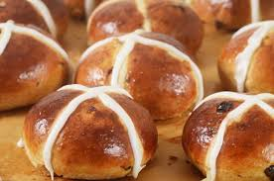

Y6
Textiles: Combining Different Fabric Shapes
Context: Transition, July Jamboree | Possible ideas: Design and make toys to sell at the July Jamboree, Design and make a pencil case for secondary school
- Focus: Textiles: Combining Different Fabric Shapes
Objectives:
- Generate and communicate innovative ideas through research.
- Produce detailed lists of equipment and fabrics and formulate step-by-step plans for making.
- Investigate and analyse textile products linked to their final product and compare the final product to the original design specification.
- Know that a 3-D textile product can be made from a combination of pattern pieces, fabric shapes and different fabrics and that fabrics can be strengthened, stiffened and reinforced.
TINKERCAD is free CAD software that can be accessed directly online by the whole class – suitable for upper Keystage 2
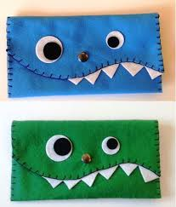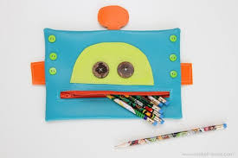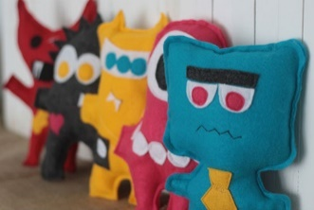

Useful Resources:
- The Design and Technology Association website – some curriculum/skill information and free resources.
- Twinkl has some OK posters, Powerpoints and images to illustrate ideas.
- TinkerCAD: a free online computer aided design software. You need to register as a teacher and then join your class – https:/www.tinkercad.com/joinclass/4QHCRU434L6I

