Y1
Textiles: templates and joining techniques
Context: Seasons and Weather/Everyday materials/Literacy context | Possible ideas: Design a warm/sun hat for a teddy/puppet making
Focus: Textiles – templates and joining techniques
- Design a functional and appealing product for a chosen user and purpose.
- Generate and communicate ideas – talking, drawings
- Explore and evaluate existing textile products and their own ideas and products.
- Use a range of textiles, tools and equipment to perform practical tasks.
- Understand how 3d textile products are made.
- Use templates to make 2 identical shapes.
- Use a simple joining technique – running stitch
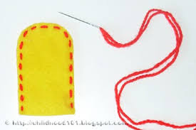

Mechanisms – wheels and axles
Context: Inventors | Possible ideas: invent a vehicle
Focus: Mechanisms – invent a vehicle using wheels and axles.
- Generate ideas and simple design criteria.
- Develop and communicate ideas through drawing and mock-ups
- Select a range of tools and equipment and materials to perform practical tasks.
- Explore wheels and axles and evaluate their ideas and products against their original criteria.
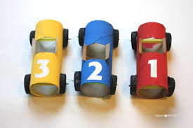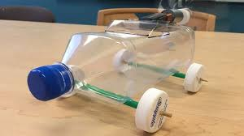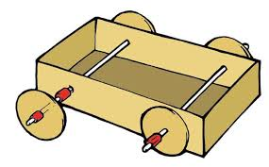

Food: preparing fruit and vegetables
Context: Ourselves/July Jamboree Enterprise | Possible ideas: Fruit Kebabs
- Focus: Food – preparing fruit and vegetables.
- Food and nutrition – looking at a varied diet.
- Generating ideas and communicate through talking, drawing
- Select from a range of fruits.
- Using simple equipment: peelers, chopping board, knives
- Evaluating taste and preferences against original criteria.
- Understanding where ingredients come from and that they are the basis of a healthy and varied diet.
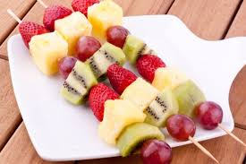

Useful Resources:
- The Design and Technology Association website – some curriculum/skill information and free resources.
- Twinkl has some OK posters, Powerpoints and images to illustrate ideas.

Y2
Structures: freestanding structures
Context: Amazing Places and Spaces/Castles | Possible ideas: design bridges/castles
Focus: Structures – freestanding structures.
Objectives:
- Generate design ideas – modelling, explaining using talk, mock-ups and drawings.
- Exploring existing freestanding structures.
- Planning, making, selecting tools and materials, using finishing techniques.
- Know about strengthening structures – knowledge of vocabulary
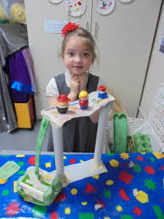

Mechanisms: Sliders and Levers
Context: Animals/Plants | Possible ideas: Make animals with moving parts/plants that grow/books with moving parts
Focus: Mechanisms – sliders and levers
Objectives:
- Generating, modelling and communicating ideas.
- Planning, making, selecting tools and using finishing techniques.
- Exploring books and products; evaluating own product against original criteria.
- Exploring sliders and levers, understanding types of movement, technical vocabulary
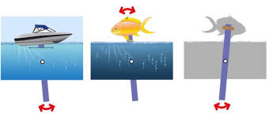

Food: preparing fruit and vegetables
Context: July Jamboree Enterprise | Possible ideas: Fruit or veg salads
Focus: Food – preparing fruit and vegetables
Objectives:
- Food and nutrition – looking at a varied diet.
- Designing an appealing product for a user
- Investigating fruit and vegetables and generating ideas, talking, drawing
- Selecting a range of fruit and vegetables; using simple equipment: peelers, chopping board, knives
- Tasting and evaluating user’s preferences; evaluating ideas and finished products against original criteria
- Understanding where ingredients come from and that they are the basis of a healthy and varied diet.
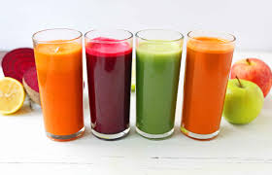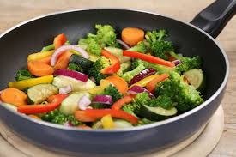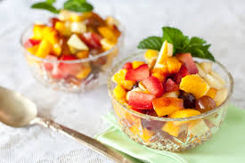

Useful Resources:
- The Design and Technology Association website – some curriculum/skill information and free resources.
- Twinkl has some OK posters, Powerpoints and images to illustrate ideas.

