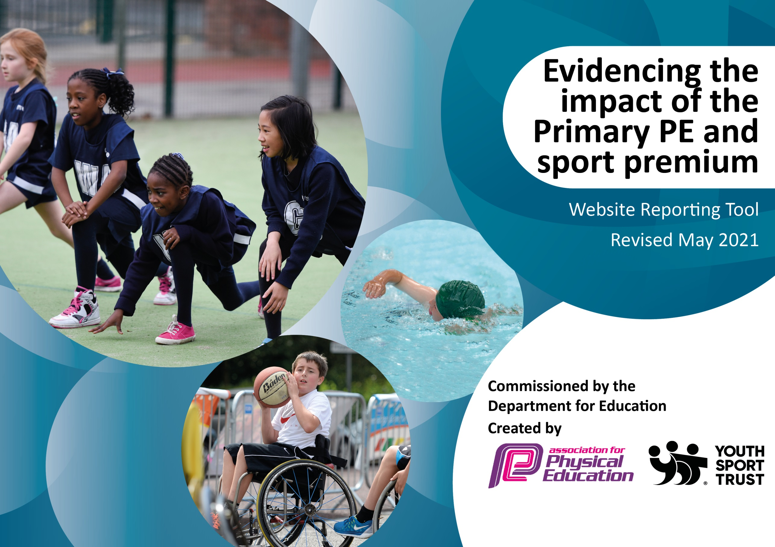

It is important that your grant is used effectively and based on school need. The Education Inspection Framework (Ofsted 2019 p64) makes clear there will be a focus on ‘whether leaders and those responsible for governors all understand their respective roles and perform these in a way that enhances the effectiveness of the school’.

Under the Quality of Education criteria (p41) inspectors consider the extent to which schools can articulate their curriculum (INTENT), construct their curriculum (IMPLEMENTATION) and demonstrate the outcomes which result (IMPACT).

To assist schools with common transferable language this template has been developed to utilise the same three headings which should make your plans easily transferable between working documents.

Schools must use the funding to make additional and sustainable improvements to the quality of Physical Education, School Sport and Physical Activity (PESSPA) they offer. This means that you should use the Primary PE and sport premium to:

- Develop or add to the PESSPA activities that your school already offer
- Build capacity and capability within the school to ensure that improvements made now will benefit pupils joining the school in future years
- The Primary PE and sport premium should not be used to fund capital spend projects; the school’s budget should fund these.
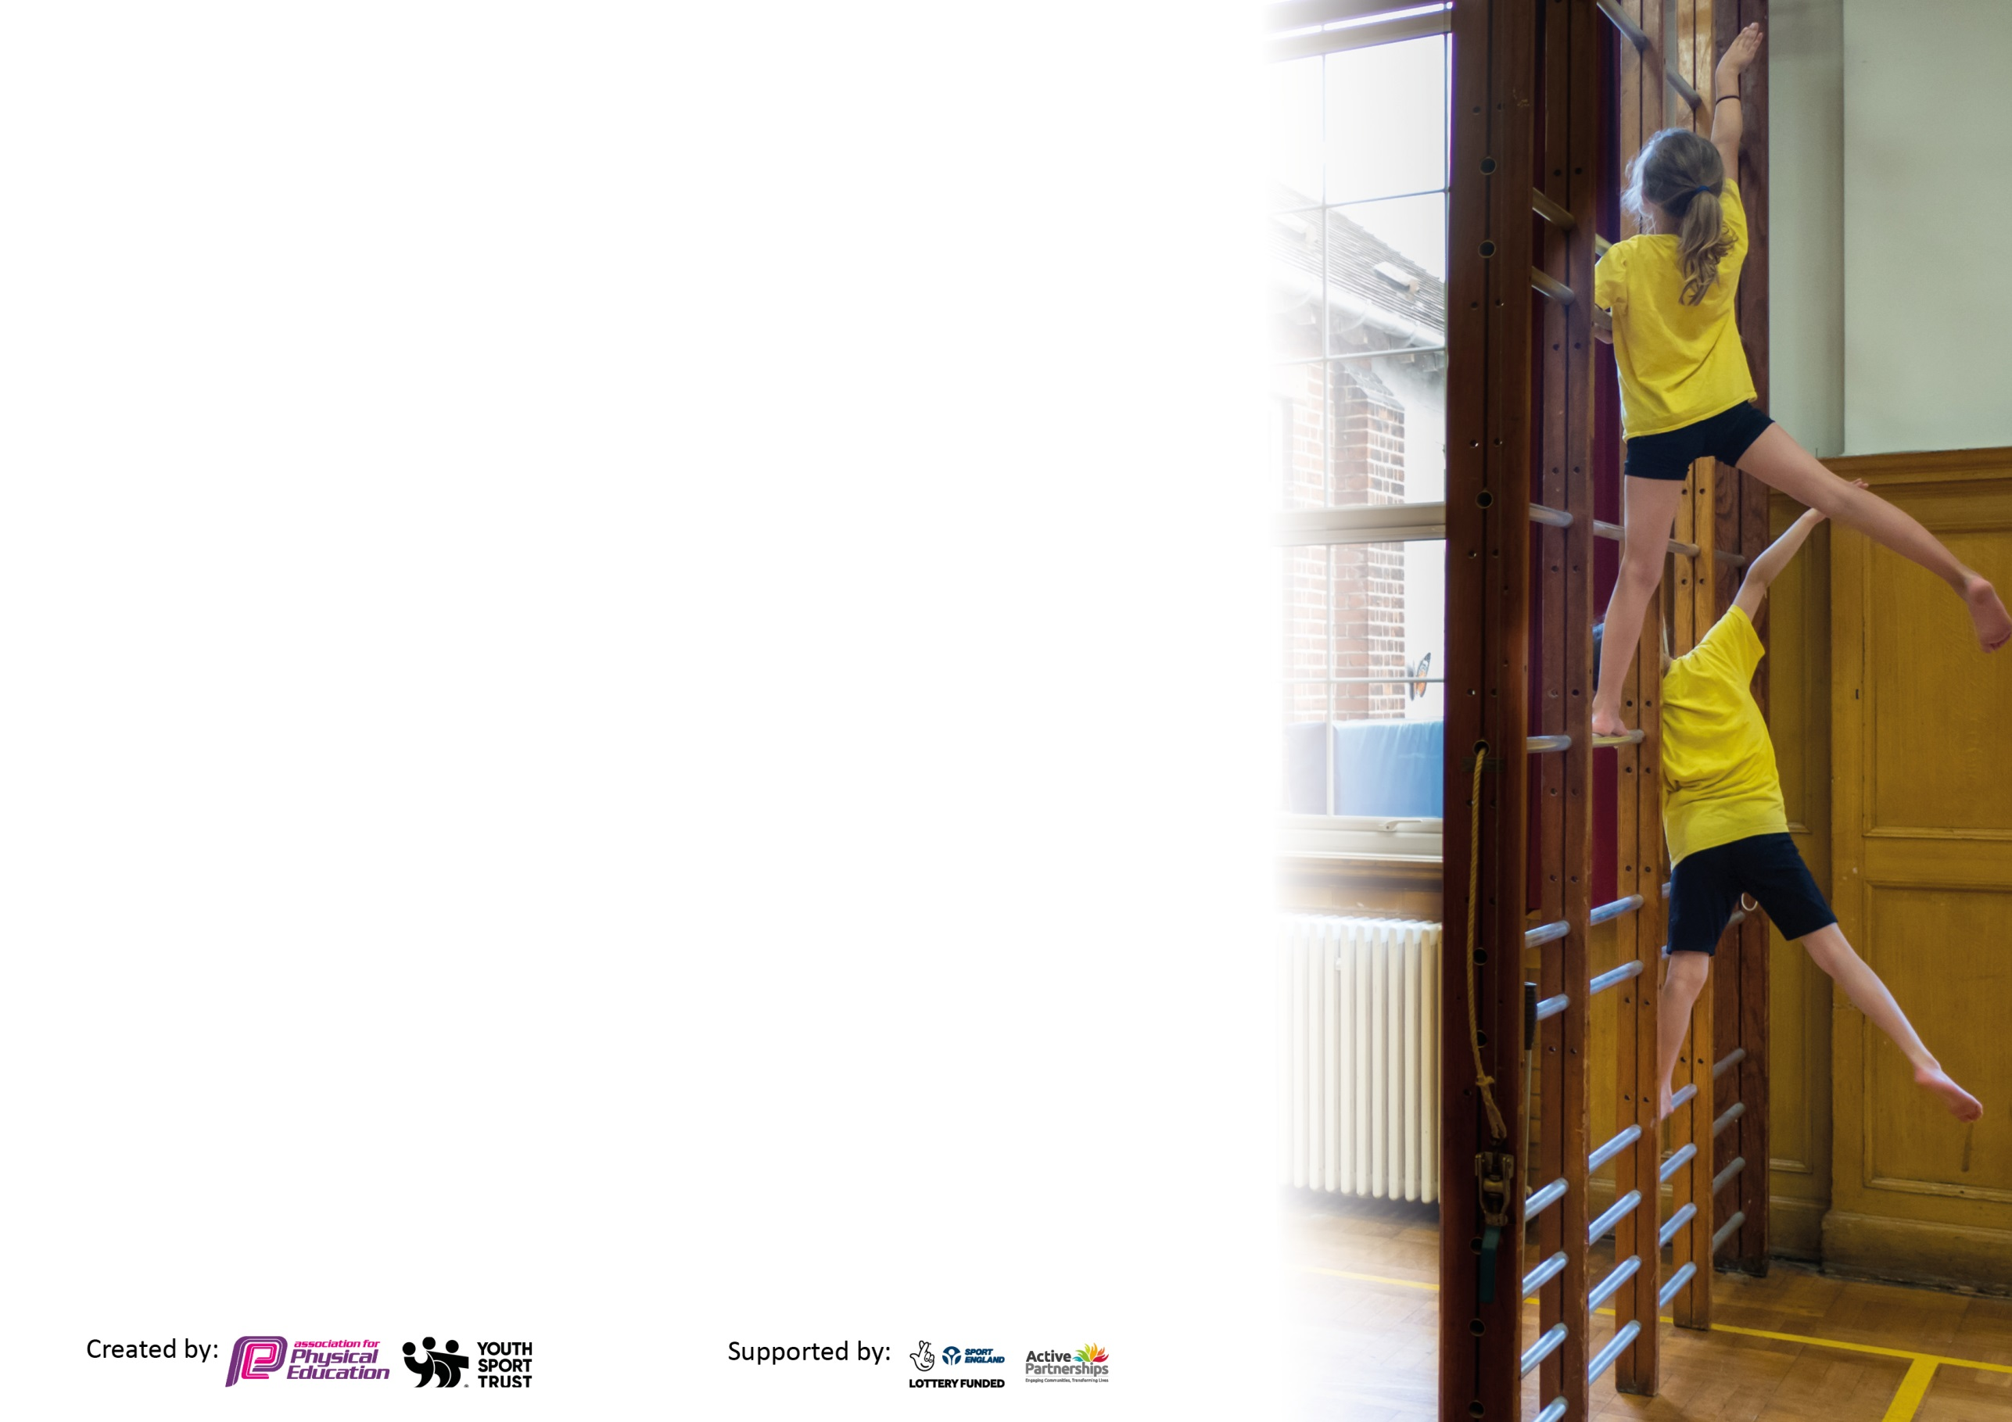
Please visit gov.uk for the revised DfE guidance including the 5 key indicators across which schools should demonstrate an improvement. This document will help you to review your provision and to report your spend. DfE encourages schools to use this template as an effective way of meeting the reporting requirements of the Primary PE and sport premium.

We recommend you start by reflecting on the impact of current provision and reviewing the previous spend.

Schools are required to publish details of how they spend this funding, including any under-spend from 2019/2020, as well as on the impact it has on pupils’ PE and sport participation and attainment by the end of the summer term or by 31st July 2021 at the latest.

We recommend regularly updating the table and publishing it on your website throughout the year. This evidences your ongoing self-evaluation of how you are using the funding to secure maximum, sustainable impact. Final copy must be posted on your website by the end of the academic year and no later than the 31st July 2021. To see an example of how to complete the table please click HERE.

Please note: Although there has been considerable disruption in 2020 it is important that you publish details on your website of how you spend the funding - this is a legal requirement.
Support for review and reflection - considering the 5 key indicators from DfE, what development needs are a priority for your setting and your pupils now and why? Use the space below to reflect on previous spend and key achievements and areas for development.

N.B. In this section you should refer to any adjustments you might have made due to Covid-19 and how these will influence further improvement.
Key achievements to date until July 2021: | Areas for further improvement and baseline evidence of need:
Swimming results are the best we’ve had, as the current Y6’s have been swimming since they were in Y2. Pupils have been able to continue with swimming lessons this year apart from during the lockdown.  Orienteering has become more high profile this year. All classes have covered this area of the curriculum, which hasn’t happened in the past. KS2 took part in bubble competitions on the Ponderosa organised by the sports partnership. This has improved staff interest and confidence to organise their own class competitions in the school playground and other local parks. | For the last 2 years, Y2 haven’t been able to swim, so we need to try and give extra lessons to these classes, to maintain this level in the future. We also need to track individuals who have been in school since Y2 as well as the whole class.  Staff need to share good practise and resources for others to use next year.

Did you carry forward an underspend from 2019-20 academic year into the current academic year? YES/NO * Delete as applicable
Total amount carried forward from 2019/2020 £1,950
+ Total amount for this academic year 2020/2021 £17,720
= Total to be spent by 31st July 2021 £

Meeting national curriculum requirements for swimming and water safety.  N.B Complete this section to your best ability. For example you might have practised safe self-rescue techniques on dry land which you can transfer to the pool when school swimming restarts.  Due to exceptional circumstances priority should be given to ensuring that pupils can perform safe self rescue even  if they do not fully meet the first two requirements of the NC programme of study. | 97%
What percentage of your current Year 6 cohort swim competently, confidently and proficiently over a distance of at least 25 metres?  N.B. Even though your pupils may swim in another year please report on their attainment on leaving primary school at the end of the summer term 2021.  Please see note above. | 69%
What percentage of your current Year 6 cohort use a range of strokes effectively [for example, front crawl, backstroke and breaststroke]?  Please see note above. | 86%
What percentage of your current Year 6 cohort perform safe self-rescue in different water-based situations? | 97%
Schools can choose to use the Primary PE and sport premium to provide additional provision for swimming but this must be for activity over and above the national curriculum requirements. Have you used it in this way? | Yes

Action Plan and Budget Tracking
Capture your intended annual spend against the 5 key indicators. Clarify the success criteria and evidence of impact that you intend to measure to evaluate for pupils today and for the future.

Academic Year: 2020/21 | Total fund allocated: £17,720+£1950 (c/f)= £19,670 | Date Updated: August 2021
Key indicator 1: The engagement of all pupils in regular physical activity – Chief Medical Officers guidelines recommend that primary school pupils undertake at least 30 minutes of physical activity a day in school |  |  |  | Percentage of total allocation:
 |  |  |  | £1750 9%
Intent | Implementation |  | Impact
Your school focus should be clear what you want the pupils to know and be able to do and about  what they need to learn and to  consolidate through practice: | Make sure your actions to achieve are linked to your intentions: | Funding allocated: | Evidence of impact: what do pupils now know and what can they now do? What has changed?: | Sustainability and suggested next steps:
All pupils will be engaging in 30-60 minutes physical activity each day. Levels of obesity will start to decline and children will be active throughout lunchtimes as well as playtimes and other times of the day. | Children in Y6 to be trained as Play leaders to encourage active playtimes in KS1 – training provided by Sports Partnership.  Play leaders to create videos for KS1 while covid restrictions are in place.  KS1 children to give feedback on their favourite games, so play leaders can plan future activities.  Introduce a range of personal challenges for children to work towards at playtimes and lunchtimes.  Inventory of playground equipment for each bubble, carried out termly and resources purchased accordingly – Learning Mentor leading. KS2 children to have a say in how their allocation is spent. (pupil voice)  Purchase an outdoor speaker for dance and skipping activities in the playground.  PE subject leader to research further ideas to break up lessons and re-energise or calm pupils throughout the day. Produce a list of activities/resources for staff to access.  More staff to be trained in Balanceability in EYFS and KS1.  All classes to complete a heatmap showing levels of activity throughout the week. Staff to try and increase activity in lessons and consider more outdoor learning.  Engage with the LA led Eat Smart Sheffield and work towards the Healthy Schools accreditation  PE subject leader to organise after school clubs where possible, including virtual activities. Also, to provide activities for bubbles who might be self-isolating at home.  Continue to develop the Gardening Club and purchase additional resources.  Set up links with community gardening group.  Yearly subscription to Playpod for resources | (see Sports Partnership below – funding still spent as this was a package)  £200 (not spent)  S/L release time £200  £200 – Not spent due to Covid-19 restrictions  £150  £1000 | Training for Y6 was cancelled due to isolation of the trainer.  Skipping ropes purchased for each class to work towards personal challenges. Children watched videos to learn new skills and seen practising at playtimes. Also used for home learning during lockdowns and brain breaks. Children persevered with the harder challenges and were excited when they met their targets. Fitness levels improved.  Playground equipment purchased for bubbles.  Outdoor speaker not purchased.  A list of websites was given to staff including fitness, dance and yoga activities. Staff also given a list of activities for emotional regulation, from trauma informed training. Children enjoyed the activities and regularly requested them, when they were in need of a break.  Staff in KS1 worked alongside the trained staff member and now take groups on their own. This has allowed more flexibility and ensured sessions have continued throughout the year. More children have been able to take part than in previous years.  Heat maps not completed but all classes prioritised PE, increasing to 3 lessons per week. Classes also did regular brain breaks and walks in the local area. Other outdoor activities such as gardening took place and outdoor lessons. Children enjoyed being more active and spending time outdoors.  Not completed.  Afterschool clubs for football and lacrosse took place and were well attended. Children were signposted to virtual afterschool activities. Virtual dance classes were provided to classes who isolating, plus skipping ropes and other online activities.  Gardening activities took place in class bubbles rather than clubs. Rain jackets allowed children to go out in all weather. Children planted seeds for flowers, which have improved the school environment. They also planted vegetables, which helped improve their understanding of science work on plants. Children have shown great enthusiasm for gardening and gone on to plant seeds at home.  Children and staff have spoken with the gardening group when out on walks and discussed projects but not yet set up firm links.  Contributions continued – during parts of the year access to the playpod was limited. Alternative resources to use in school, e.g. for craft, were sent instead at times. | Playleaders to be arranged for September for Y6 class.  Videos to be created if not mixing with KS1 children. Play leaders to devise personal challenges for playtimes.  Playground equipment to continue to be restocked.  Repeat skipping targets work, so children can build on skills and work towards new targets.  Further research needed for outdoor sound system.  Staff encouraged to make time for the activities next year.  Continue to share knowledge with staff in KS1 and Foundation stage.  Heatmaps to be completed for new timetables in term 1.  Carry forward healthy schools work.  Work with Zest to increase clubs and activities. Increase work with Sheffield university students.  Make stronger links with the gardening group. Explore possible gardening activities at the care home. Develop the club within school, to more year groups.
Key indicator 2: The profile of PESSPA being raised across the school as a tool for whole school improvement |  |  |  | Percentage of total allocation:
 |  |  |  | £11550 58%
Intent | Implementation |  | Impact
Your school focus should be clear what you want the pupils to know and be able to do and about  what they need to learn and to  consolidate through practice: | Make sure your actions to achieve are linked to your intentions: | Funding allocated: | Evidence of impact: what do pupils now know and what can they now do? What has changed?: | Sustainability and suggested next steps:
To raise achievement in swimming by the end of KS2.  By swimming regularly over a series of years, pupils will develop good swimming skills. They will develop confidence and will feel encouraged to participate in out of school swimming activities.  The amount of children being able to swim unaided for a sustained distance will continue to increase year on year.  To provide children with appropriate resources to support high quality learning.  To showcase and celebrate PE and Sport across school throughout the year. | Purchase additional blocks for swimming, enabling all children from Y2- Y5 to participate in swimming lessons.  PE lead to work closely with school swimming service to improve quality of lessons and progress of swimmers.  PE lead will support class teachers to deliver water safety lessons in class, prior to swimming lessons, to increase the amount of time in the water.  PE subject leader carry out regular audits of equipment and replenishing stock termly.  Purchase of an interactive Whiteboard for use in Sports Hall to improve teaching and learning in PE lessons. (including internet access and speakers)  PE subject leader to organise celebratory events in bubbles or virtually. e.g. Dance show, orienteering festival, skipathon  Class teachers to celebrate achievements in PE in class assemblies, giving certificates. Share videos of performances with another class.  Regular updates to be put on the website and school notice board.  Form sports committee and give tasks to class sports leaders in KS2. | £4050  £7,500  £7,000 (originally allocated – overspend of £500) | Y5 completed most of their block but after lockdown we prioritised Y3 and Y4 as they also missed lessons last year. The children have progressed well and only a few in each class are struggling with water confidence. Some Y3s have progressed from complete non swimmers to swimming more than 10m without arm bands.Y2 didn’t swim this year.  PE lead and teachers have worked closely with the swimming teachers and the swimming service to ensure good progress, despite covid restrictions. Swimming results are improving, with this year being the highest yet.  Water safety power points have been given to staff and they have been delivered in class. Children have found it easier to listen in a classroom situation and with access to visuals. They were more likely to ask questions and take part in discussion, than when it was previously delivered by the swimming teachers.  PE equipment was replenished when needed, ensuring children didn’t need to share and equipment could be separated for different bubbles.  Whiteboard and sound bar has been installed and used in PE lessons. This has given staff renewed enthusiasm for teaching PE and easier access to music and videos when needed. It has allowed children to see examples of good practice and have visuals to remind them of teaching points throughout the lesson.  KS1 and KS2 took part in the Sheffield Skipathon.  F2 to Y6 took part in the ‘Beat the Street’ challenge.  KS2 took part in an orienteering competition. KS1 took part in a mini Olympics festival.  Classes made videos of dances from their dance lessons and shared with other classes.  Certificates of achievements have been given in shine award assemblies.  Photos of activities have been shared on the school noticeboard and the website, but needs to be done more regularly.  Sports committee not formed due to covid restrictions. | An additional block of lessons to be purchased next year, to catch up on missed lessons over the last 2 years. This should allow lessons from Y2-Y6 next year.  PE lead to research resources to use on the interactive whiteboard during PE lessons. Staff to be supported in using the whiteboard in lessons.  When restrictions are lifted, more celebratory events to be organised across school. In the meantime, continue to share virtually.  Encourage staff to share more pictures on the school website.  Sports committee to be formed when restrictions allow.

Key indicator 3: Increased confidence, knowledge and skills of all staff in teaching PE and sport |  |  |  | Percentage of total allocation:
 |  |  |  | £5770 29%
Intent | Implementation |  | Impact
Your school focus should be clear | Make sure your actions to | Funding | Evidence of impact: what do | Sustainability and suggested
what you want the pupils to know | achieve are linked to your | allocated: | pupils now know and what | next steps:
and be able to do and about | intentions: |  | can they now do? What has
what they need to learn and to |  |  | changed?:
consolidate through practice:
To continue to improve the quality of swimming lessons and results at the end of KS2  Continue to develop the role of the PE subject leader, in order to maintain or raise the quality of PE taught to KS1 and KS2 pupils  Improve the quality of balance and bike riding skills across school. (particularly EYFS and KS1) This will help improve concentration and link to focused learning in class. It will also support development of core strength and stamina of children. | Further TAs to attend swimming training if available, to enable supporting of nervous children in the water.  Work closely with the swimming service to make changes to teaching and recording of data, to suit our specific needs.  Due to GDPR concerns, individual data for each child needs to be collected by class teachers for Zest swimming staff. This will help make data more accurate with regard to filtering children who have attended swimming lessons over the course of primary school.  PE lead to support staff in delivering water safety aspects of the curriculum in school.  Prioritise year groups to swim, depending on pool closures due to covid 19. Work with the swimming service to ensure covid procedures are secure and efficient.  Work with the sports partnership to provide curriculum support in gymnastics. (area where there is least staff confidence)  Class teachers to work with a dance teacher to develop subject confidence. Teachers from Y1-6 to receive half a term of modelled teaching.  Participate in Primary Stars, delivered by SUFC. Teachers from Y1-Y6 to receive 1 term of modelled teaching.  PE subject leader to support new staff in teaching of PE.  Complete the progression of PE skills in dance and gymnastics, based on Chris Quigley/Val Sabin for each year group and publish on website.  SLT provide support for PE subject leader to monitor and develop use of PE reflection books and assessment.  HLTA to work with groups of Y1 children regularly using balance bikes and accompanying activity suggestions.  HLTA to train new Y1 TA, in how to use balance bikes effectively and the principles behind using them.  (Extend to EYFS staff when restrictions allow)  Continue scooter skills training for Y1/Y2 if available.  Arrange Bikeability lessons in Y5 and Y6.  Continue to organise for bike health checks so more children have safe bikes to use. (if available) | £1,100  £1,970  £2500  £200 – not spent | No further training this year but those already trained have supported children in the water and helped to build confidence more quickly.  Results are now recorded in class groups for the term rather than blocks of 18 weeks. Continuity of swimming teachers and keeping records of swimming groups has allowed classes to get started more quickly, at the start of the term.  Still waiting to receive registers from swimming service, when lessons have ended abruptly due to lockdowns.  Water safety power points have been given to staff and they have been delivered in class. Children have found it easier to listen in a classroom situation and with access to visuals. They were more likely to ask questions and take part in discussion, than when it was previously delivered by the swimming teachers.  Changes made to PE long term plans after the lockdown to prioritise Y3 and Y4 who missed swimming in the last 2 years due to lockdowns. PE lead has maintained regular contact with the swimming service and ZEST pool operators to ensure covid procedures are secure and efficient. This resulted in very little disruption to the actual swimming lessons.  2 blocks of work have been completed with Y4 and Y6 class teachers on gymnastics, led by a specialist from the sports partnership. Children really enjoyed the lessons and staff confidence was raised. Staff are confident to repeat the blocks of work independently next year.  Staff have enjoyed working with a dance teacher and feel more confident to guide children in the future. Children have learned a lot of dance moves that can be used for their own creative routines in the future. Videos have been available on the school website and children have been keen to practise at home, raising the profile of dance across the school.  Staff have benefitted from seeing a professional football coach lead lessons, learning coaching tips and progressions in teaching football. Children have become more skilful, as they’ve built on coaching from last year. KS2 classes have also enjoyed the after school club.  Support given to staff in delivering orienteering scheme of work. Staff are more confident and more orienteering sessions have taken place this year.  Progression of skills has been completed and shared on the school website.  This hasn’t been a focus this year, due to the pandemic.  HLTA has worked with other staff in KS1 to give more flexibility in delivery. Groups have been taking place throughout the year, uninterrupted by staff absence. More staff are now confident to lead the groups. Children have caught up on missed learning last year. More of the bigger bikes were purchased, which are more suitable for Y1 children, so allows bigger groups of children to ride together. Pedal bike also purchased for those ready to progress.  Not done due to covid.  Not done due to covid.  Not done due to covid. | Identify staff for virtual training course.  Continue to work with the swimming service to improve tracking of individuals’ progress.  PE lead to find additional resources on water safety, to support those provided by the swimming service.  Continue to work with the swimming service regarding covid procedures, if still in place.  Additional blocks of swimming to allocated on the long term plan to classes who have missed the most lessons.  Target 2 more classes to work with the sports partnership coach, to develop confidence in teaching gymnastics.  Hopefully, if restrictions allow, children will work towards performing their dances to an audience.  Aim to set up a dance club next year and encourage dancing in the playground by making music available.  Continue to work with SUFC to provide coaching for classes, further development of coaches and an after school club. Next year we will hopefully take part in more competitions. PE lead to work with SUFC to provide more opportunities for competition.  No new staff, but support to be given where needed.  PE lead to look at how the gymnastics session plans from the sports partnership work with the Chris Quigley skills.  Continue with this next year.  HLTA to work with F2 staff to start cycling before KS1.  Continue next year.  Continue next year.  Continue next year.
Key indicator 4: Broader experience of a range of sports and activities offered to all pupils |  |  |  | Percentage of total allocation:
 |  |  |  | £600 3%
Intent | Implementation |  | Impact
Your school focus should be clear | Make sure your actions to | Funding | Evidence of impact: what do | Sustainability and suggested
what you want the pupils to know | achieve are linked to your | allocated: | pupils now know and what | next steps:
and be able to do and about | intentions: |  | can they now do? What has
what they need to learn and to |  |  | changed?:
consolidate through practice:
Children across KS1 and KS2 will have opportunities to try a new sport/s that they might not access outside school.  Children will feel proud of their achievements and may decide to pursue these sports or activities outside of school.  Children will have the opportunity to participate in unusual activities that they are unable to experience within school. They will have opportunities to challenge themselves and develop new skills and self-confidence | PE subject leader to identify potential sports for each class to try. Eg yoga, lacrosse  Pupil surveys in each class taken by sports committee members to establish interests of children.  Work with the university and Zest where possible, to set up taster sessions and clubs.  Subsidise the Y5/Y6 trip to Thornbridge Outdoor Activity centre so that children can participate in bike riding, low and high ropes, orienteering and other outdoor activities. Likely to be daytrips rather than residential this year. | Not spent due to cancellation of trip Covid-19 (£600) | Limited due to covid restrictions.  Y1, Y2 and Y3 took part in orienteering for the first time.  Y6 continued with their lacrosse club, a sport not easily accessed in the community.  All classes benefitted from professional coaching in dance and football.  KS2 continued with swimming lessons and children were encouraged to take swimming lessons outside of school.  Thornbridge cancelled due to covid. Day trips also limited due to covid. | Continue with lacrosse club and work with Sheffield university students to add more activities.  Build closer working relationship with ZEST in order to sign post children to out of school activities.  Build closer links with SUFC and signpost children to out of school sessions where available.  Pick up work with Yorkshire cricket, that hasn’t taken place during the pandemic.  When possible, organise work with Thornbridge and Whirlow.  Organise training for staff member for low ropes and cycling.

Key indicator 5: Increased participation in competitive sport |  |  |  | Percentage of total allocation:
 |  |  |  | £0 0%
Intent | Implementation |  | Impact
Your school focus should be clear | Make sure your actions to | Funding | Evidence of impact: what do | Sustainability and suggested
what you want the pupils to know | achieve are linked to your | allocated: | pupils now know and what | next steps:
and be able to do and about | intentions: |  | can they now do? What has
what they need to learn and to |  |  | changed?:
consolidate through practice:
To increase the opportunities all children in KS1 and KS2 have to participate in sporting events and competitions. | PE subject leader to attend Sports Partnership training and conferences, if available. If not, to maintain regular contact with the partnership team via email and phone.  Long term plan in PE organized to reflect Sports Partnership competition programme.  PE subject leader to organise for classes to participate in a range of virtual competitions. (stemming from the Sports Partnership – see KI 1 for funding information).  Plan intra competitions between different classes, within bubbles.  Introduce personal challenges for children to work on within their class bubble.  Ensure all classes are recording data for the running challenge and presenting certificates. | No additional cost this year, due to school being able to find subject release time in school | PE subject leader maintained regular contact with the partnership team.  Limited programme of competitions due to covid. Classes competed in virtual competitions in athletics and football in term 1. Children worked towards personal bests in athletics from previous years.  KS2 took part in bubble competitions in orienteering, rounders and sports day races.  KS1 took part in a mini Olympics and kick rounders competition.  All classes worked towards personal challenges in skipping, linked to the skipping festival. All classes took part in ‘Beat the Street’ walking/biking/scootering challenge. Children motivated to walk to school, after school and at the weekends. Also noticed a number of children getting fitness watches, for counting steps and comparing their steps with each other and staff.  Classes also worked towards the running challenge and received certificates for different distances towards a marathon. Class charts were displayed in classrooms. | PE lead to work with the sports partnership to access a range of competitions throughout the year.  Adjust the long term plans to work with the competition programme.  Continue to promote virtual competitions.  Try to increase the number of intra competitions.  Repeat skipping challenge and running challenge. Add further challenges next year.  Continue next year and engage with other running/walking challenges that are available.

Signed off by
Head Teacher: | Elizabeth Gray
Date: | 01.09.21
Subject Leader: | Corinne O’Neill
Date: | 30.7.21
Governor: | Kathryn Rangeley
Date: | 23.09.2021

