Key vocabulary
vertebrate | Animals that have a backbone. They can be divided into 5 groups: fish, amphibians, reptiles, birds and mammals.
invertebrate | Animals that do not have a backbone. Can be divided into several groups including insects, spiders, snails and worms.
arachnid | An animal that has eight legs and a body formed of two parts
crustacean | Animals which mostly live in water with a hard shell and segmented body
microorganism | A microscopic organism, especially a bacteria, virus or fungus
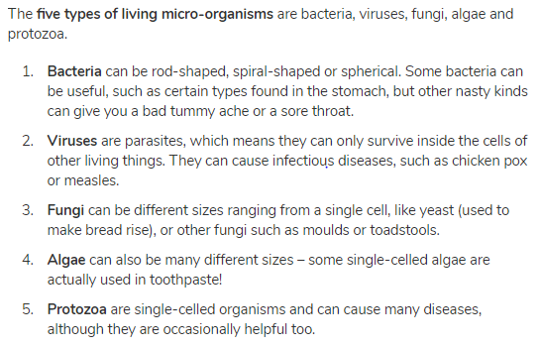

Classification
Living things can be classified into broad groups according to observable characteristics that are similar or different.

Living things and their habitats – Year 6
Significant scientists
Carl Linnaeus  (1707-1778)  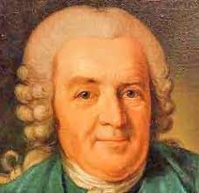 | Carl Linnaeus was a Swedish scientist who developed the modern system of classifying and naming organisms. Before this the names of living things were often very long. He gave them a two-part name.
Chris Nelson  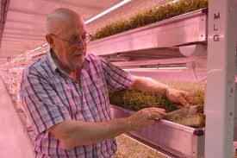 | Chris Nelson is a horticulturist and a director of Growing Underground which uses hydroponic techniques to grow pesticide-free crops in a former London underground air-raid shelter.
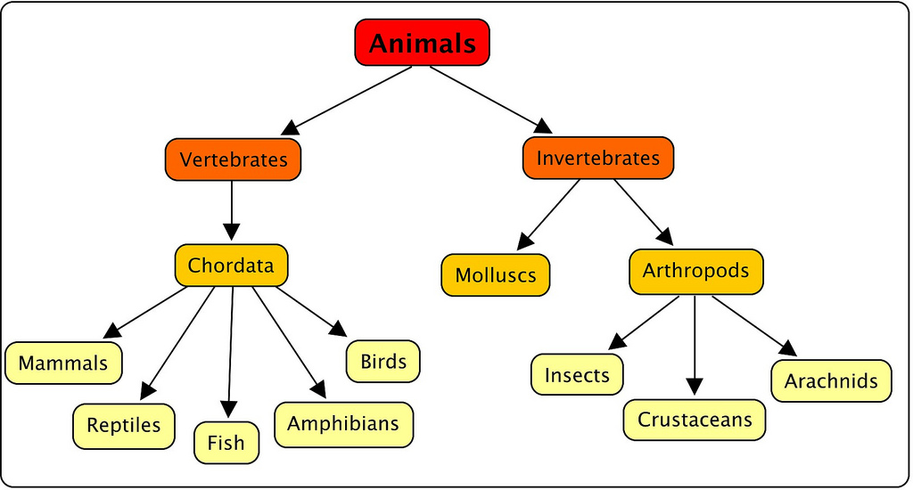

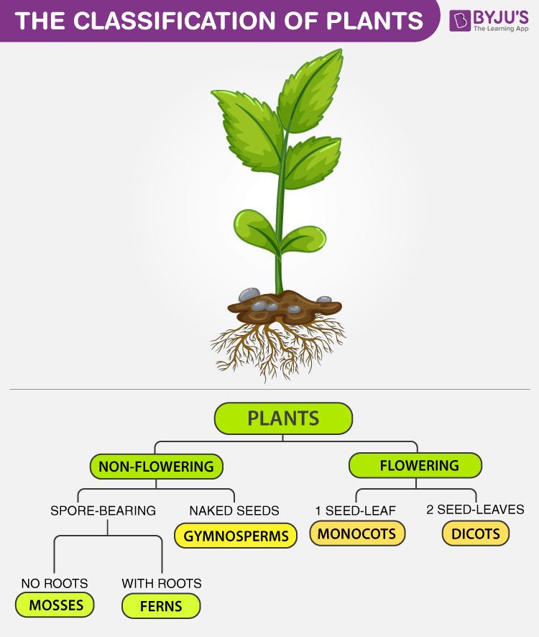
Flowering plants – numerous and diverse group. Reproduce through flowers and seeds. E.g. sunflower
Non-flowering plants – smaller group. They have a simple structure and do not have flowers or seeds. They reproduce through spores. E.g. algae, mosses
