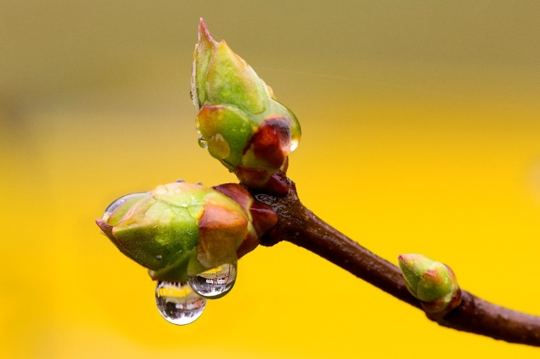
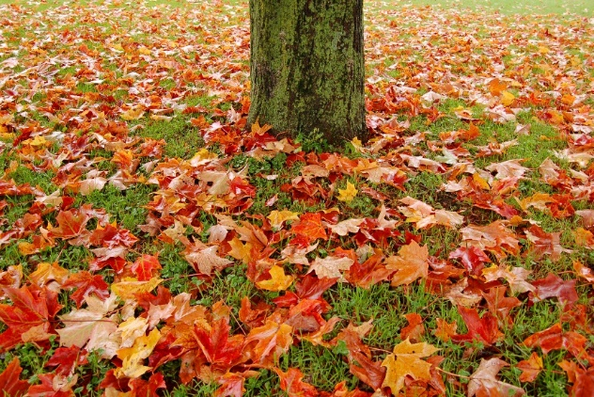
Knowledge organiser – Weather and Seasons
What will we be learning?
- Months of the year and seasons.
- Differences between the seasons.
- Features of different seasons.
- Clothing worn in different weather.
- Weather types in the UK.
- How the weather affects different jobs.
Key facts
The months of the year:
January, February, March, April, May, June, July, August, September, October, November, December.

The seasons of the UK:
autumn, winter, spring and summer
Key knowledge
In the UK, there are four different seasons. Each season has different weather types.
Winter is cold, wet and windy. It snows in some areas and gets dark early.
Spring brings warmer weather. Flowers start to grow and baby lambs are born.
In summer, the weather becomes hotter; there is often less rain, but there may be thunderstorms.
The weather starts to get colder in autumn. Leaves change colour and fall off the trees.

Place names | Geographical terms and processes | Locational terms
Antarctica  Earth  My school | rain  season  snow  sunshine  temperature  wind | Arctic  inside  outside  polar
Glossary
rain gauge: a tool you can use to show how much it has rained
season: a time of the year with a particular type of weather
temperature: how hot or cold it is
weather forecast: explaining what the weather will be like

