Y3
Structures: Shell Structures (boxes, nets)
Context: July Jamboree Enterprise (design packaging for a product) | Possible ideas: Design and make packaging for a fragile product, exploring the relationship between the shape and strength of the structure. Or design a desk tidy – structures and stability, 3d shapes.
Focus: Structures: shell structures
Objectives:
- Generating and developing realistic ideas and design criteria collaboratively and through analysis of existing products.
- Order the stages of making; selecting tools and using with some accuracy.
- Investigate and evaluate shell structures from real products.
- Construct strong, stiff shell structures.
- Test and evaluate own products against design criteria and intended user and purpose.

Food: Healthy and Varied Diet
Context: Animals including Humans | Possible ideas: Design a Super Salad, Design healthy dips and dipper, Design a Super Smoothie
Focus: Food: Healthy and Varied Diet
Objectives:
- Generate ideas and develop design criteria for an appealing product for a chosen user and purpose.
- Plan the main stages of a recipe, listing ingredients, utensils and equipment.
- Select from a range of ingredients to make appropriate food products.
- Carry out and record evaluations of a variety of ingredients and products.
- Know a range of appropriate ingredients, and whether they are grown, reared or caught.
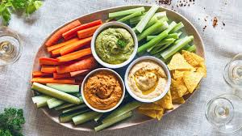
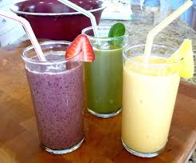

Textiles: 2d Shape to 3d Product
Context: Tokyo, Brazil, The Sahara | Possible ideas: Design and make a bag for a specific user and purpose
Focus: Textiles: 2d shape to 3d product.
Objectives:
- Generate design criteria for an appealing, functional product for specific users.
- Produce annotated sketches, prototypes, final product sketches and pattern pieces.
- Select fabric and fastenings according to their functional characteristics.
- Investigate a range of 3d textile products.
- Test their products against the original criteria and with the intended user.
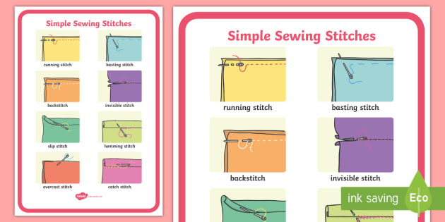

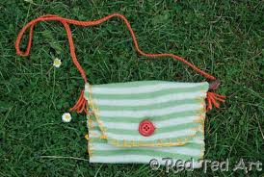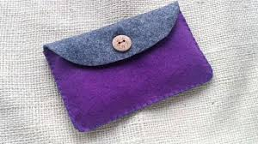

Useful Resources:
- The Design and Technology Association website – some curriculum/skill information and free resources.
- Twinkl has some OK posters, Powerpoints and images to illustrate ideas.
- TinkerCAD: a free online computer aided design software. You need to register as a teacher and then join your class – https:/www.tinkercad.com/joinclass/4QHCRU434L6I. Probably more suitable for upper Key stage 2

Y4
Mechanical Systems: Levers and Linkages
Context: History/Literacy: Ancient Egypt, The Roman Empire, Viking and Anglo Saxon, | Possible ideas: design a moving history book
Focus: Mechanical Systems: levers and linkages
Objectives:
- Generate realistic ideas and use annotated sketches and prototypes to develop, model and communicate ideas.
- Select and use tools with some accuracy to cut, shape and join paper and card.
- Investigate and analyse their own and other’s products with lever and linkage mechanisms.
- Understand and use lever and linkages, and fixed and loose pivots.
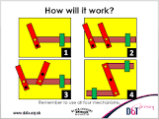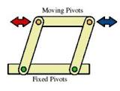

Electrical Systems: Simple Circuits and Switches
Context: Electricity; sound | Possible ideas: design an alarm for a vehicles (buzzers), design a torch
Focus: Electrical Systems: simple circuits and switches
Objectives:
- Use annotated sketches, cross sectional and exploding diagrams to develop and communicate ideas.
- Select and use tools with some accuracy to cut, shape, join and finish.
- Use construction materials and electrical components according to their functional properties and aesthetic qualities.
- Understand and use electrical systems in their products, such as series circuits incorporating switches, bulbs and buzzers.
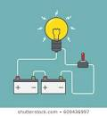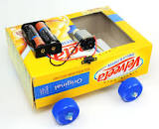
Y4
Food: Healthy and Varied Diet
Context: July Jamboree Enterprise, Animals, including Humans | Possible ideas: design and make Healthy flapjacks, Healthy muffins, Savoury muffins, super smoothies,
- Focus: Food – healthy and varied diet.
- Generate ideas and develop design criteria for an appealing product for a user and purpose.
- Plan the main stages of a recipe, listing, ingredients, utensils and equipment.
- Select from a range of ingredients, to make appropriate food products.
- Carry out and record evaluations of a variety of ingredients and products.
- Know a range of appropriate ingredients, and whether they are grown, reared or caught.
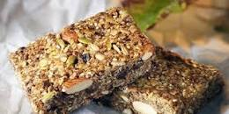

Useful Resources:
- The Design and Technology Association website – some curriculum/skill information and free resources.
- Twinkl has some OK posters, Powerpoints and images to illustrate ideas.
- TinkerCAD: a free online computer aided design software. You need to register as a teacher and then join your class – https:/www.tinkercad.com/joinclass/4QHCRU434L6I. Probably more suitable for upper Keystage 2.

