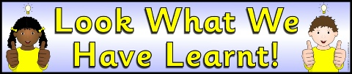
History
This week we have been learning about what life was like for school children in the Victorian times. We have been learning about the subjects they learnt, the games they used to play and the punishments they’d get if they weren’t following the rules!
Practise our playground song for the Mayor’s performance on Tuesday. (see separate sheet)

Literacy
Linked to our History, we have been doing some descriptive writing about how life felt like for a child at school in the Victorian times.
Using the photos on the next page, can you describe life for a Victorian school child?

Science
This week we visited the Yorkshire Wildlife Park to see all of our science learning in action. We had a wonderful time seeing so many different animals in their habitats and spotted lots of microhabitats throughout the park. We were also able to talk about what living things eat and food cycles.

Spellings
Keep practising your Year 1 and 2 Common Exception Words. Spellings will be checked on Monday and were sent home earlier in the week. As a reminder, here are the spellings that will be checked next.

Miss Sindano’s phonics group: push, pull, full, house, our, after, again, any, bath, beautiful

Miss Ost’s phonics group: child, children, Christmas, class, climb, clothes, could, cold, door, even

