Knowledge Organisers
These one page, fully editable knowledge organisers have been put together to support teachers when introducing a topic to their pupils. All of the knowledge organisers work alongside Oddizzi’s schemes of work, pathway document and the year group vocabulary and glossary banks.
Suggested Use
- Encourage prior research
- Discussed as a class at the beginning of a topic
- Stuck into books to refer back to throughout the unit
- Displayed in the classroom for reference
- Setting expectations for vocabulary to be used by pupils in their learning
Structure
Each organiser contains:
- A summary of what will be covered in each unit of study
- Key Facts
- Key Knowledge
- A vocabulary list split into three helpful categories: place names, geographical terms and processes and locational terms
- Key glossary terms chosen from Oddizzi’s Progression in Vocabulary document
- Pictures

Please note: as this resource is a fully editable Word document, the layout may shift slightly depending on the version of Word you have opened it with. The same applies if you choose to add/edit/delete anything in the document.

Knowledge organiser – Rivers
What will we be learning?
- What a river is.
- How rivers are used.
- The features of a river.
- How rivers are affected by humans.
- The impact of flooding.
- Facts about the world’s longest rivers.
Key facts
The world’s ten longest rivers (the longest three first):

Nile (Africa), Amazon (South America), Yangtze (Asia), Mississippi (North America), Yenisei (Asia), Yellow (Asia), Ob-Irtysh (Asia), Paraná (South America), Congo (Africa), Amur (Europe/Asia).
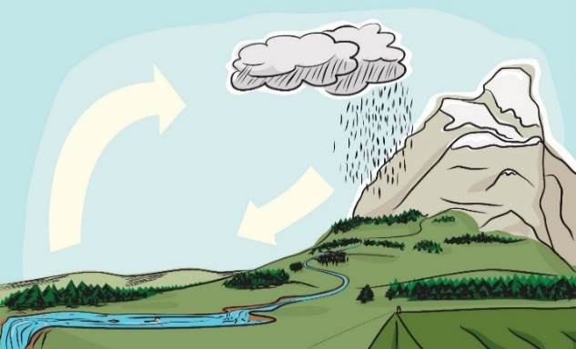
Key knowledge
The water cycle is the way in which water moves around the Earth. It never stops!
Rivers have many uses around the world, including cleaning, cooking, growing crops, transport and creating power.
A river has three main stages: upper course, middle course and lower course.
Flooding is caused by poor drainage around or close to a river.
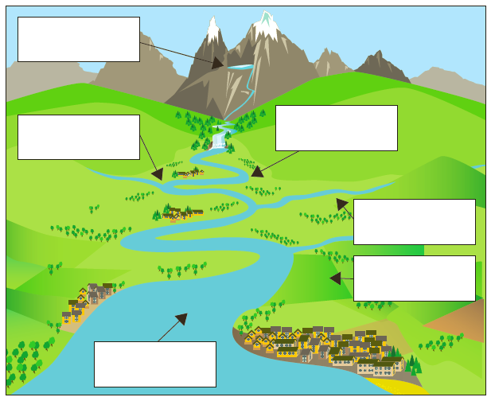
Source
Confluence
Mouth
Tributaries
Flood plain
Meander

Place names | Geographical terms and processes | Locational terms
Egypt  Ethiopia  South Sudan  Sudan  Uganda  United States of America | confluence  flood plain  meander  mouth  source  tributary | altitude  estuary  lower course  middle course  upper course
Glossary
drainage: how water flows away from an area through rivers and streams
erosion: how wind, water and waves break down and remove rock and soil
flood management: stopping or controlling floods
irrigation: the supply of water, especially for growing crops

