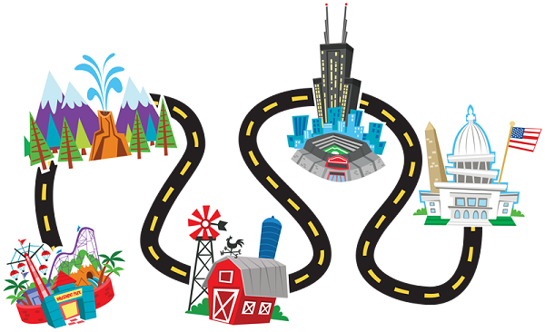

**Our Local Area**

**What will we be learning?**

* Differences between urban and rural areas
* Features of our school grounds.
* Features of our local area
* How to identify Ordnance Survey map symbols
* How to create a map of our local area

|  |
| --- |
|  |
| **Key Vocabulary:**  Address  City  Rural  Urban  Physical features  Human features  Local  Map  Direction  Distance  Journey  Route  Travel  Left  Right  Straight on  North  South  East  West | |

**Key Knowledge**

An urban area has lots of people living there. Towns, cities and suburbs are all urban areas.

A rural area has fewer people living there. Rural areas include the countryside, villages and hamlets.

An Ordnance Survey map is used to help people find their way around an area.

**Glossary**

**map symbol**: *a small picture on a map that shows you where different things are (such as a bus station or a school)*

**route**: *how you get from one place to another (for example, “you walk up the hill and turn towards the school when you get to the top)”*

**physical features:** *like seas, mountains and rivers are****natural****. They would be here even if there were no people around.*

**human features:**  like houses, roads and bridges are things that have been **built by people.**

**Types of houses**

Flats/Tower block

Semi detached house

Bungalow

Terraced house

Detached house

Maisonettes